Section I: Scenario Demographics

Scenario Title: | Tumour Lysis Syndrome (TLS)
Date of Development: | 24/02/2016 (DD/MM/YYYY)
Target Learning Group: | Juniors (PGY 1 – 2) Seniors (PGY ≥ 3) All Groups

Section II: Scenario Developers

Scenario Developer(s): | Donika Orlich (modified case Dysrhythmia secondary to hyperkalemia by Kyla Caners)
Affiliations/Institution(s): | McMaster University
Contact E-mail (optional): | Donika.orlich@medportal.ca

Section III: Curriculum Integration

Learning Goals & Objectives
Educational Goal: | To expose learners to a case of Tumour Lysis Syndrome with severe hyperkalemia, hyperuricemia and hypocalcemia as its metabolic complications.
CRM Objectives: | - Demonstrate leadership by maintaining a global perspective and organizing team to deliver multiple drug therapies  - Utilize resources appropriately by calling for help when indicated  - Demonstrate problem solving ability by implementing concurrent management approach and avoiding fixation error  - Employ communication skills to obtain an immediate code status from a family member
Medical Objectives: | - Recognize hyperkalemia on ECG and initiate ED therapy  - Investigate for the possibility of tumour lysis syndrome in the setting of recent chemotherapy for hematologic cancer by highlighting the importance of serum electrolyte levels and their distrubances, including hyperuricemia.  - Considers indications for treatment of hypocalcemia in the ED setting  - Consults nephrology for dialysis

Case Summary: Brief Summary of Case Progression and Major Events
A 72-year-old male is brought in as a “code STEMI” to the resuscitation bay. He was recently diagnosed with ALL and had chemotherapy 3 days ago for the first time. The patient is severely hyperkalemic, which must be initially recognized and treated, hypocalcemic and hyperuricemic as a result of Tumour Lysis Syndrome and the metabolic derangements must be stabilized until emergent hemodialysis is arranged.

References
Pfennig CL, Slovis CM. (2013). Electrolyte disorders. In J. Marx, R. Hockberger & R. Walls (Eds.), Rosen's emergeny medicine - concepts and clinical practice. pp. (1636-51). Philadelphia, PA.:Saunders.
Website: accessed on April 14, 2015: http://lifeinthefastlane.com/ecg-library/basics/hyperkalaemia/
Website: accessed on Feb 24, 2016: http://lifeinthefastlane.com/ccc/tumour-lysis-syndrome/

Section IV: Scenario Script

A. Scenario Cast & Realism
Patient: | Computerized Mannequin |  |  |  |  | Realism:  Select most important dimension(s) |  |  | Conceptual
 | Mannequin |  |  |  |  |  |  |  | Physical
 | Standardized Patient |  |  |  |  |  |  |  | Emotional/Experiential
 | Hybrid |  |  |  |  |  |  |  | Other:
 | Task Trainer |  |  |  |  |  |  |  | N/A
Confederates | Brief Description of Role
Wife: | The wife arrives with the patient. The wife will stress the fact that he would not want CPR or intubation unless the acute condition is reversible. She will ask the team leader directly “is this a reversible problem?”. The wife will then ask general questions (“what’s happening now?”) and will follow directions if asked to leave the bedside.
B. Required Monitors
EKG Leads/Wires |  |  | Temperature Probe |  |  |  | Central Venous Line
NIBP Cuff |  |  | Defibrillator Pads |  |  |  | Capnography
Pulse Oximeter |  |  | Arterial Line |  |  |  | Other:
C. Required Equipment
Gloves |  |  | Nasal Prongs |  |  |  | Scalpel
Stethoscope |  |  | Venturi Mask |  |  |  | Tube Thoracostomy Kit
Defibrillator |  |  | Non-Rebreather Mask |  |  |  | Cricothyroidotomy Kit
IV Bags/Lines |  |  | Bag Valve Mask |  |  |  | Thoracotomy Kit
IV Push Medications |  |  | Laryngoscope |  |  |  | Central Line Kit
PO Tabs |  |  | Video Assisted Laryngoscope |  |  |  | Arterial Line Kit
Blood Products |  |  | ET Tubes |  |  |  | Other:
Intraosseous Set-up |  |  | LMA |  |  |  | Other:
D. Moulage
None required.

E. Approximate Timing
Set-Up: |  | 3 min |  | Scenario: | 15 min |  |  | Debriefing: |  | 30 min

Section V: Patient Data and Baseline State

A. Clinical Vignette: To Read Aloud at Beginning of Case
72M complaining of general weakness for 2 days. His wife called EMS and he was a STEMI patch to your hospital. He has been placed in the resuscitation bay.
B. Patient Profile and History
Patient Name: Geoff Brady |  |  |  |  |  | Age: 72 |  |  |  |  |  |  |  | Weight: 80kg
Gender: M F |  |  |  |  |  | Code Status: DNR
Chief Complaint: Weak and dizzy
History of Presenting Illness: Felt unwell since waking up this morning. Feels light headed with standing and like he “has no energy.” Nauseous. Has newly diagnosed ALL and had his first round of chemotherapy 3 days ago.
Past Medical History: |  | ALL |  |  |  |  | Medications: |  |  |  |  | Ramipril 5mg OD
 |  | HTN |  |  |  |  |  |  |  |  |  | Crestor 20mg OD
 |  | Dyslipidemia |  |  |  |  |  |  |  |  |  | Cisplatin
Allergies: Penicillin
Social History: Retired. Lives with his wife. No EtOH/smoking/illicit drug use.
Family History: No hx CAD. All have diabetes.
Review of Systems: |  | CNS: |  |  | Generally weak.
 |  | HEENT: |  |  | Nil.
 |  | CVS: |  |  | No CP. No palps.
 |  | RESP: |  |  | No SOB.
 |  | GI: |  |  | Nausea.
 |  | GU: |  |  | Nil
 |  | MSK: |  |  | Muscle cramps and paresthesia’s |  |  |  |  |  |  |  | INT: |  | Nil.
C. Baseline Simulator State and Physical Exam
No Monitor Display |  |  |  | Monitor On, no data displayed |  |  |  |  |  |  | Monitor on Standard Display
HR: 50/min |  |  | BP: 92/65 |  |  |  |  | RR: 16/min |  |  |  |  |  |  | O₂SAT: 97% RA
Rhythm: Idioventricular |  |  | T: 36.4ºC |  |  |  |  | Glucose: 12.7 mmol/L |  |  |  |  |  |  | GCS: 13 (E3 V4 M6)
General Status: Slightly diaphoretic. Looks unwell.
CNS: | A+Ox3. No focal neurologic deficits. No asterixis.
HEENT: | PERLA. 3mm.
CVS: | Normal S1/S2. No murmur.
RESP: | GAEB. No adventitious sounds.
ABDO: | Soft, NT.
GU: | Nil.
MSK: | Nil. |  |  |  |  |  |  |  | SKIN: | No rashes.

Section VI: Scenario Progression

Scenario States, Modifiers and Triggers
Patient State | Patient Status | Learner Actions, Modifiers & Triggers to Move to Next State
1. Baseline State  Rhythm: idioventricular  HR: 50/min  BP: 92/65  RR: 20/min  O₂SAT: 97% RA  T: 36.4ºC | Diaphoretic, awake, answering questions. Feels dizzy. | Learner Actions  - IV, O2, monitors  - ECG  - Blood work including trop, extended lytes, uric acid, lactate  - Fluid bolus  - Check cap sugar (12.7)  - Administer calcium gluconate 1g (10-30ml) iv  - ± ASA 160mg PO chew | Modifiers  Changes to patient condition based on learner action  - Calcium given HR 70, QRS narrows (change to sinus)  - Fluid bolus BP 102/67  Triggers  For progression to next state  - Calcium not given by 3 min 2. Arrest  - Initial work-up complete and calcium given 4. VBG Back
2. Arrest  Rhythm Asystole  BP -/-  RR 0  O₂SAT ? | Unresponsive with no vitals. | Learner Actions  - Quality CPR  - Calcium chloride 1-2 amps  - NaHCO3 amps  - Epinephrine amps  - 1 amp D50 then insulin R 10 units iv | Modifiers  - 7 minutes into case critical VBG back showing hyperkalemia  Triggers  - Calcium given 3. NSR
3. NSR  Rhythm sinus  HR 70  BP 105/70  RR 16  O₂SAT 97% RA | Awake and responding. | Learner Actions  - Ventolin 20mg nebulized, 24 puffs, or 0.5mg IV  - 1amp D50 then insulin R 10 units iv (if not yet done)  - Repeat ECG  - ± HCO3 amp  - Call nephro re: dialysis | Modifiers  - Ventolin given HR 90  Triggers  - Two treatments for hyperK given and Nephro called 4. Blood Work Back  - 12 minutes 4. Blood Work Back
4. VBG Back  Rhythm sinus  HR 70  BP 105/70 | Awake, alert, no longer feels dizzy. | Learner Actions  - Ventolin 20mg nebulized, 24 puffs, or 0.5mg IV  - 1amp D50 then insulin R 10 units iv  - Repeat ECG  - ± HCO3 amp  - ± Lasix 40mg iv (if still makes urine)  - Call nephro re: dialysis | Modifiers  - Given critical VBG result showing hyperkalemia as state starts  - Ventolin given HR 90  Triggers  - Two treatments for hyperK given and Nephro called 4. Blood Work Back  -12 minutes 4. Blood Work Back
5. Blood Work Back | Patient still complaining of muscle crams, otherwise better. | Learner Actions  - Recognize likely Tumour Lysis syndrome  - IV NV bolus (goal u/o 2cc/h)  - Allopurinol (600-800mg/d)  - Rasburicase  - ± Lasix 20mg IV (hyperK, volume overload, poor u/o)  - IV Calcium gluconate (1-2g over 10 minutes)  - Call MedOnc re admission  - Call Nephro for dialysis consideration | Modifiers  - Given lab results showing hyperuricemia, hyperphosphatemia and hypocalcemia as state starts  - If no treatment for hyperuricemia initiated, phone call from the “Lab” informing that the “Urate and calcium at a level that must be treated”,  Triggers  - Considers or initiates a treatment for hyperuricemia and hypocalcemia given AND Nephro called for urgent dialysis-> END CASE  *Consideration of treatment includes voicing that hem/onc will be consulted for guidance in treatment.

Section VII: Supporting Documents, Laboratory Results, & Multimedia

Laboratory Results
Critical VBG:  pH 7.27  PCO2 35  PO2 45  HCO3 20  Lactate 2.5  Na 142  K 8.6  Cl 105 | Labs:  Troponin: 5  INR: 1.0  WBC: 8  Neuts: 1.0  Hb: 140  Plt: 300  Urate 400 umol/L (high)  Cr: 650 umol/L (high)  PO4: 3.0 mmol/L (high)  Ca: 1.98 mmol/L (low)

Images (ECGs, CXRs, etc.)
ECG 1: Hyperkalemia STEMI mimic  (Source: http://lifeinthefastlane.com/ecg-library/basics/hyperkalaemia/) | 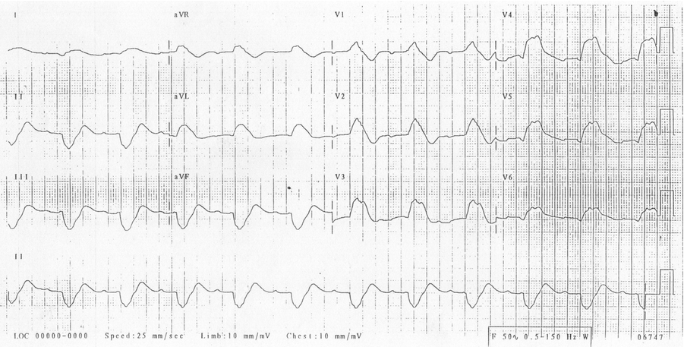
ECG 2: NSR with no ST changes  (Source: http://cdn.lifeinthefastlane.com/wp-content/uploads/2011/12/normal-sinus-rhythm.jpg) | 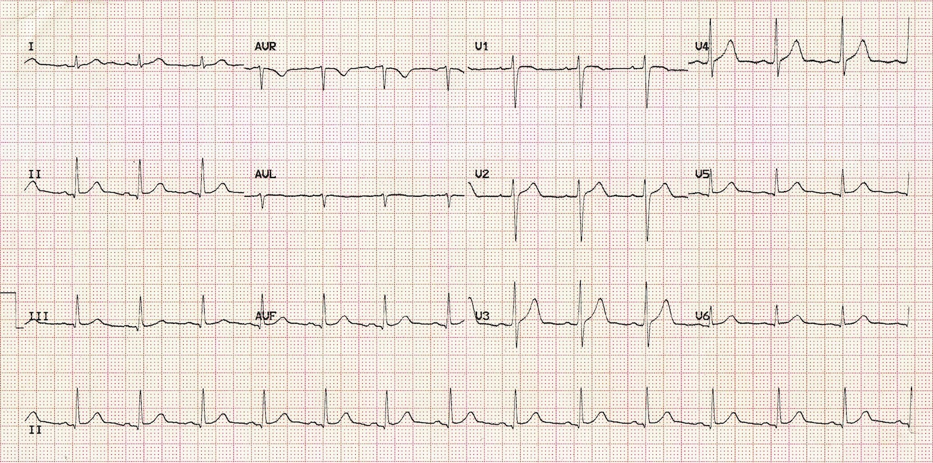

Section VIII: Debriefing Guide

General Debriefing Plan
Individual | Group |  | With Video | Without Video
Objectives
Educational Goal: |  | To expose learners to a case of Tumour Lysis Syndrome with severe hyperkalemia, hyperuricemia and hypocalcemia as its metabolic complications.
CRM Objectives: |  | - Demonstrate leadership by maintaining a global perspective and organizing team to deliver multiple drug therapies  - Utilize resources appropriately by calling for help when indicated  - Demonstrate problem solving ability by implementing concurrent management approach and avoiding fixation error  - Employ communication skills to obtain an immediate code status from a family member
Medical Objectives: |  | - Recognize hyperkalemia on ECG and initiate ED therapy  - Investigate for the possibility of tumour lysis syndrome in the setting of recent chemotherapy for hematologic cancer by highlighting the importance of serum electrolyte levels and their distrubances, including hyperuricemia.  - Considers indications for treatment of hypocalcemia in the ED setting  - Consults nephrology for dialysis
Sample Questions for Debriefing
- What are the ECG changes associated with hyperkalemia?
- What are some mimics of ST elevation on an ECG?
- What lab abnormalities can be seen with tumour lysis syndrome? What causes each?
- What are symptoms of hypocalcemia? What is the risk in treating it?
Key Moments
Identification of hyperkalemia on ECG.
Alteration of ACLS management to include copious calcium and HCO3 in context of hyperkalemia
Recognition of Tumor Lysis Syndrome as the cause of hyperkalemia and initiation of therapy aimed at hyperuricemia and symptomatic hypocalcemia.

